Before you can use the HTML Tag Library, you
have to "import" it into the JSP with the following line at the top of the JSP:
<%@ taglib uri="http://struts.apache.org/tags-bean" prefix="bean" %>
<%@ taglib uri="http://struts.apache.org/tags-html" prefix="html" %>
<%@ taglib uri="http://struts.apache.org/tags-logic" prefix="logic" %>

<!-- Global Forwards Configuration -->
<global-forwards>
<forward name="search" path="/search.jsp"/>
</global-forwards>
Forward definitions allow you to declaratively configure the location to which a link points instead of hard-coding that information into your JSP or application

<bean:message key="label.search.name"/>
The message tag allows externalized messages from the MessageResources.properties resource
bundle file to be inserted into the JSP at run time. The message tag simply looks up the key passed
to it in MessageResources.properties and returns the corresponding message from the file.

Html tags
bean tags
logic tags
message property files

<html:text property="name"/></td>
The property "name" here corresponds to the field named name in the SearchForm object. That
way, when the tag is executed, it places the value of the name field in the HTML at run time.

<!-- Message Resources Configuration -->
<message-resources
parameter="com.jamesholmes.minihr.MessageResources"/>

logic:iterate indexId="index" name="" id="" property=""

Model Layer
Action subclasses interact with the Model via interfaces and use its Data Transfer Objects to pass and retrieve data
You should not place any business logic or data access code in Action objects
your Model code should not have any references to Struts code or objects
Form Beans are used to collect form data which eventually must be transferred to
the Model layer code for processing.
org.apache.commons.beanutils.PropertyUtils class and use its copyProperties(
) method to transfer fields from one object to the other. The destination object is the first parameter to
the copyProperties( ) method, and the origination object is the second method parameter.
The copyProperties( ) method will automatically copy all fields from the origination object to the destination object that have the same name

View Layer
It does not contain business logic, such as calculating interest for a banking application or storing items in a shopping cart for an online catalog.
The View layer also does not contain any code for persisting data to or retrieving data from a data source. Rather, it is the Model layer that manages business logic and data access. The View layer simply concentrates on the interface

Struts' HTML/JSP View layer support can be broken down into the following major components:
▪ JSP pages
▪ Form Beans
▪ JSP tag libraries
▪ Resource bundles

Form Beans are basic Java beans with getter and setter methods for each of their properties,
allowing their data to be set and retrieved easily. The org.apache.struts.action.ActionForm class is the base abstract class that all Form Beans must descend from (be it directly or via a subclass).
Because Form Beans are simple data containers, they are principally composed of fields, and getter and setter methods for those fields. Business logic and data access code should not be placed in these classes. That code goes in Model layer classes. The only other methods that should be in these classes are helper methods or methods that override ActionForm's base reset( ) and validate() methods.
The reset( ) method is a hook that Struts calls before the Form Bean is populated from an application request (e.g., HTML form submission). The validate() method is a hook that Struts calls after the Form Bean has been populated from an application request.

This example Form Bean has one field, name, that is validated in the validate( ) method.
The validate( ) method checks whether or not the name field is empty. If it is empty, it returns an error indicating that fact. The ActionErrors object is basically a collection class for
storing org.apache.struts.action.ActionMessage instances. Each validation inside the validate( ) method creates an ActionMessage instance that gets stored in the ActionErrors object.
The ActionMessage class takes a key to an error message stored in the application resource
bundle. Struts uses the key to look up the corresponding error message. Furthermore,
the ActionMessage class has constructors that take additional arguments that contain replacement values for the error message associated with the specified key.
The validate( ) method will be called unless the Action Mapping has been configured with
"validate=false" in the Struts configuration file.

If all validations in the validate( ) method pass, a return value of null indicates to Struts that no errors occurred.

Data validations can be performed in the execute( ) method of action classes; however,
having them in Form Beans allows them to be reused across multiple actions where more
than one action uses the same Form Bean. Having the validation code in each action would
be redundant.
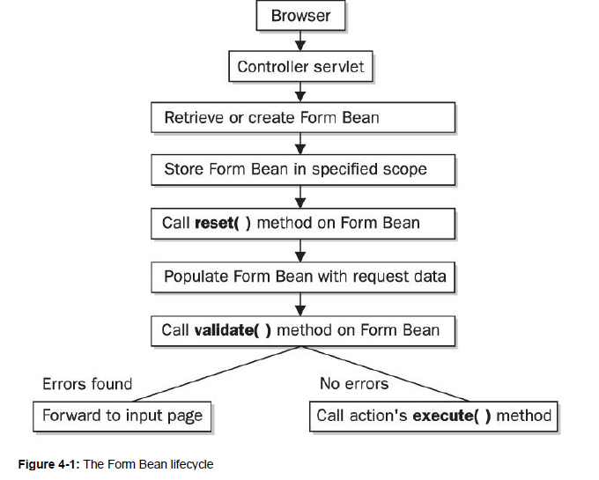
Following is an explanation of the Form Bean lifecycle. When a request is received by the Struts
controller servlet, Struts maps the request to an action class that is delegated to process the request.
If the action being delegated to has an associated Form Bean, Struts attempts to look up the
specified Form Bean in request or session scope, based on how the action is configured in the Struts
configuration file. If an instance of the Form Bean is not found in the specified scope, an instance is
created and placed in the specified scope. Next, Struts calls the reset( )method on the Form Bean so
that any processing is executed that needs to occur before the Form Bean is populated. After that,
Struts populates the Form Bean with data from the incoming request. Next, the Form
Bean's validate( ) method is called. The next step in the process is based on the return value from
the validate( ) method. If the validate( ) method records any errors and subsequently returns a nonnull
ActionErrors object, Struts forwards back to the action's input page. If, however, the return value
from the validate( ) method is null, Struts continues processing the request by calling the
action's execute( ) method.

Validation
Instead of coding validation logic in each Form Bean's validate( ) method, with Validator you use an XML configuration file to declare the validations that should be applied to each Form Bean. If you need a validation not provided by Validator, you can plug your own custom validations into Validator. Additionally, Validator supports both server-side and client-side (JavaScript) validations whereas Form Beans only provide a server-side validation interface.

Additionally, you have to write code that will store error messages for validations that fail. With Validator, you don't have to write any code in,your Form Beans for validations or storing error messages. Instead, your Form Beans extend one of Validator's ActionForm subclasses that provide this functionality for you.

The Validator framework is set up as a pluggable system of validation routines that can be applied to Form Beans. Each validation routine is simply a Java method that is responsible for performing a specific type of validation and can either pass or fail

By default, Validator comes packaged with several useful validation routines that will satisfy most validation scenarios. However, if you need a validation that is not provided by the framework, you can create your own custom validation routine and plug it into the framework.

